Ziya Gökalp Mah. İkitelli Organize Sanayi Bölgesi Atatürk Bulvarı No:50 34490 Başakşehir / İstanbul / TÜRKİYE
Telefon : +90 212 549 22 52
Faks : +90 212 549 25 80
Web : www.emasas.com.tr


EMAS ELEKTROTEKNİK MAKİNA SANAYİ VE TİCARET A.Ş

Technical Specifications : PPKS11BX10

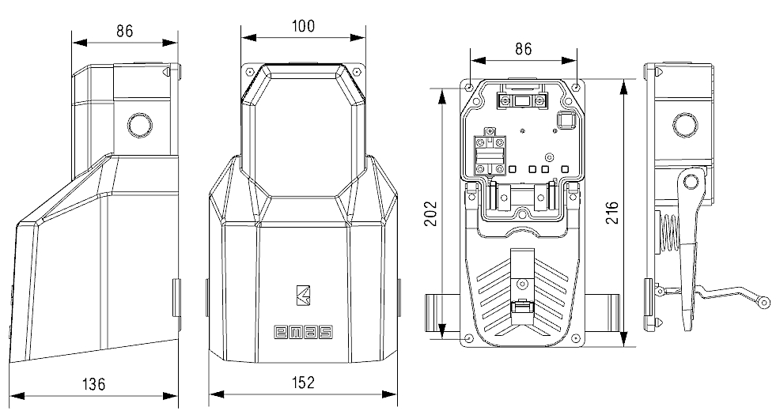

Technical Information

Standards:


Contact Block:TS EN 60947-5-1
(PDA-PD)

Body:
Plastic body
Single Cover
Single level
Maximum strength to mechanical pulses
Ergonomic usage facilitiy with 2 different sizes
Contact Block: K 13 1(1NA+1NK)

General Specifications

OperatingTemperature | min. / max. ºC -5 / +60
Mechanical Life  (Operating Frequency) | 1.000.000 operations min.  Withoud load 3000 operations / hour )
Elecrical Life  (Operating Frequency) | 100.000 operations min.  At full load 1200 operations / hour)
K13 Block Tightening Torque | 0.6-0.8N m
K13 Block Connection Wire | Min:1x0.5mm’2
Wire Profile | Max:2x2.5mm’2
Proection Degree | IP 65
General Specifications
Range Of Use |  | AC 15
Rated Operating Voltage | Ue | 250V AC
Fregquency | f | 50Hz
Rated Operating Current | Ie | 4A
Insulation Voltage | Ui | 300V
Electrical Information

