Ziya Gökalp Mah. İkitelli Organize Sanayi Bölgesi Atatürk Bulvarı No:50 34490 Başakşehir / İstanbul / TÜRKİYE

Telefon : +90 212 549 22 52

Faks : +90 212 549 25 80

Web : www.emasas.com.tr



**EMAS ELEKTROTEKNİK MAKİNA SANAYİ VE TİCARET A.Ş**

Technical Specifications : PDA2

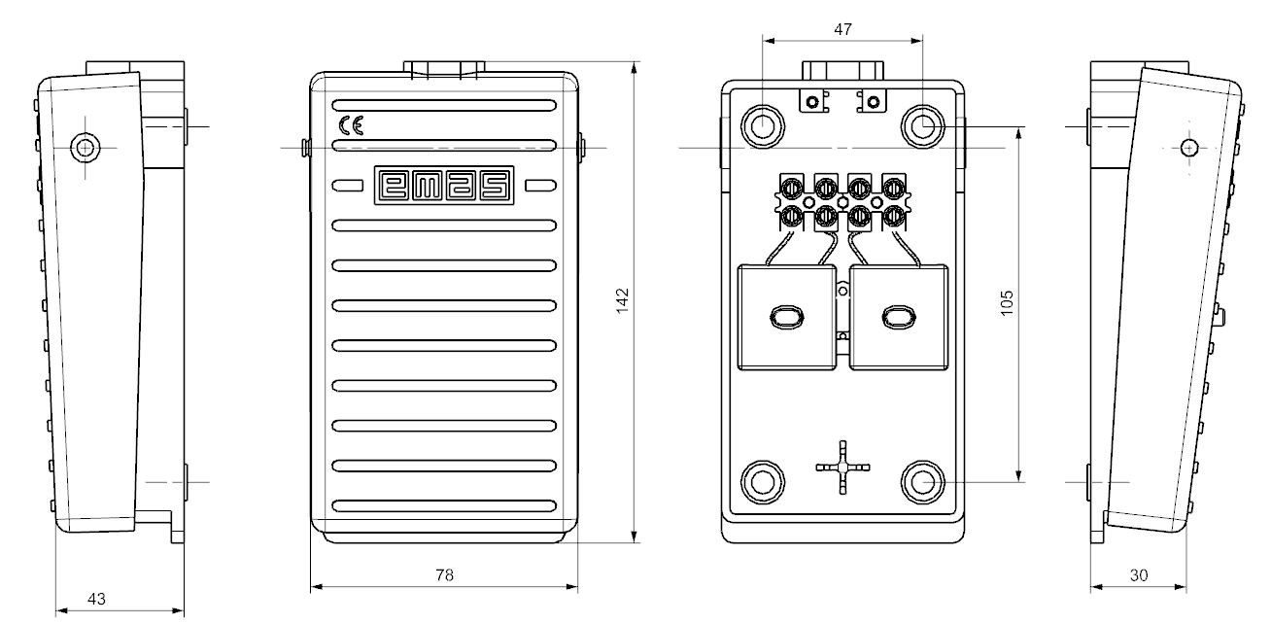

Technical Information:

|  |
| --- |
| **Body:**  Metal (green) aliminium body  Single level  Maximum strength to mechanical pulses  Ergonomic usage facilitiy with 2 different sizes  Assembly facilitiy  Contact Block: 2 KB34 2NA |

**Standards**:

  

Contact Block:

TS EN 60947-5-1

(PDA-PD)



**General Specification**

|  |  |
| --- | --- |
| OperatingTemperature | min. / max. ºC -5 / +60 |
| Mechanical Life  (Operating Frequency) | 1.000.000 operations min.  Withoud load 3000 operations / hour ) |
| Elecrical Life  (Operating Frequency) | 100.000 operations min.  At full load 1200 operations / hour) |
| KB 34 Block Tightening Torque | 0.6-0.8 Nm |
| KB 34 Block Connection Wire Profile | Min:1x0.5mm’2 |
| Wire Profile | Max:2x2.5mm’2 |
| Proection Degree | IP20 |
| Rated Operating Voltage Ue | 250 V AC |
| Rated Operating Current le | 4A |