Ziya Gökalp Mah. İkitelli Organize Sanayi Bölgesi Atatürk Bulvarı No:50 34490 Başakşehir / İstanbul / TÜRKİYE

Telefon : +90 212 549 22 52

Faks : +90 212 549 25 80

Web : www.emasas.com.tr



**EMAS ELEKTROTEKNİK MAKİNA SANAYİ VE TİCARET A.Ş**

Technical Specifications : PV5E30B22

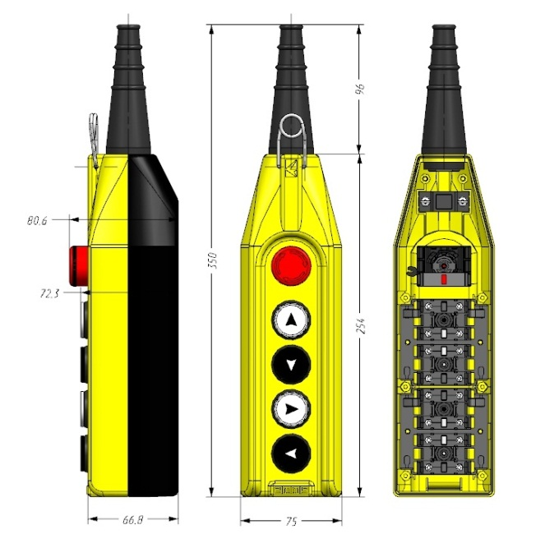

Technical Information :

**Body:**

-Suitable to Φ22mm push buttons,

-Aesthetic look and ergonomic usage with assistance of ABS reinforced material,

-Mechanical protection preventing operation in opposite direction at same moment,

-Maximum resistance to environment conditions with waterproof body and buttons,

-Single Speed

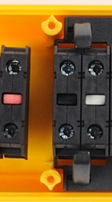-Flexible cable pipe,

-Easy assembly,

-Emergency Push Button for usage in dangerous situations.

Contact block shown in black is used for 4 **Stop.**

Contact block shown in white is used for 4 **Start.**

Contact block shown in red is used for **Emergency Stop** .

**Standards**:

- TS EN 60947 -5-1

In Contact Blocks;

VDE 0660 UL508

  

Push Buttons:

  cus

**General Specification**

|  |  |
| --- | --- |
| OperatingTemperature | min. / max. ºC -5 / +85 |
| Mechanical Life  (Operating Frequency) | 1.000.000 operations min.  Withoud load 3000 operations / hour ) |
| Elecrical Life  (Operating Frequency) | 100.000 operations min.  At full load 1200 operations / hour) |
| PV Block Tightening Torque | 0.6-0.8Nm |
| Pv Block Connection Profile | Min:1x0.5mm’2 |
| Wire Profile | Max.2x2.5mm’2 |
| Cable Dimensions | Φ8-ϕ17 |
| Proection Degree | IP65 |

Electrical Information:

**General Specifications**

|  |  |  |
| --- | --- | --- |
| Range Of Use |  | AC15 |
| Rated Operating Voltage | Ue | 250V AC |
| Fregquency | f | 50Hz |
| Rated Operating Current | Ie | 4A |
| Insulation Voltage | Ui | 300V |
| Stroke Resistance Voltage | Uimp | 2.5kV |
| Dielectrical Strenght |  | 1500V AC |
| Insulation Resistance |  | 10MΩ(500V DC) |